 

July,2019

**Presbyterian Times**

First Presbyterian Church

919 E. Tenth

Rolla, MO 65401

Telephone: 573-364-3852 / Fax: 573-426-5320

From Our Pastor

Keeping Our Baptismal Promise  
On July 16, Davon White and Jesse Kimball will be going to Triennium at Purdue University. For several days they will attend small group Bible studies, large group games, and worship with thousands of other youth. They will be meeting new people, stretching their faith, and have opportunities to grow as disciples - to learn about themselves and Christ.  When Jesse and Davon were baptized, the church promised to nurture them in their faith, to encourage their discipleship, and to provide for them a community in which they could grow up knowing God’s love. As we send them to Triennium with your financial support, we also send them with our spiritual support. On July 14 we will commission Jesse and Davon before they leave on July 15 to join the other John Calvin Presbytery youth for their journey north please prayerfully support them in their time away. Please pray for the adults who will be watching over them, and the conference leaders as they manage such a great responsibility.   
  
Bless you and thank you for keeping your baptismal promises to these precious young people.   
  
Peace,  
Lou Ellen

**Linen Closet Needs**

Queen size linens are needed for the linen closet. Sheet sets, comforters, blankets, and pillows are in low supply.

Thank you for all your donations.



[This Photo](http://www.firefliesandjellybeans.com/2012/03/deal-alert-anna-linens-biggest-bedding.html) by Unknown Author is licensed under [CC BY](https://creativecommons.org/licenses/by/3.0/)



[This Photo](http://commons.wikimedia.org/wiki/File:Three_flat_sheets.jpg) by Unknown Author is licensed under [CC BY-SA](https://creativecommons.org/licenses/by-sa/3.0/)



[This Photo](http://commons.wikimedia.org/wiki/File:White-pillows.jpg) by Unknown Author is licensed under [CC BY-SA](https://creativecommons.org/licenses/by-sa/3.0/)

|  |  |  |  |  |
| --- | --- | --- | --- | --- |
| |  |  |  | | --- | --- | --- | | |  | | --- | | **The Way Forward Committee**  *Jonathan Kimball, Chair*  The Way Forward committee is continuing its work towards the overall vision laid out back in January. Broadly speaking, the problems we are trying to solve are:   * Improve accessibility of the sanctuary to make better use of the space for worship. * Enable people with mobility issues to participate more fully in fellowship. * Create a stronger feeling of oneness and community.   To these ends, we are working on a variety of options that will incorporate fellowship space in the back part of the sanctuary and improve flow in the sanctuary seating. We are narrowing down configurations that will be evaluated by Session, and then presented to the congregation. According to our policy, the ultimate decision-making authority rests with the Session, but it is essential for the congregation to be engaged.  After the Session has had a chance to evaluate our committee’s work, we will make sure that every member has the opportunity to review the viable options and to share opinions and concerns with either a committee member (myself, Ken Kwantes, Susan Murray, Eleanor Van Horn, Lou Ellen Hartley) or with an elder on Session. We will also work with the trustees to ensure that they are a part of the process.  I understand that making changes to sacred space is emotionally challenging. I would ask everyone to prayerfully consider what the future holds for our worshipping community, where the Spirit is leading us, and how best we can use the space that we have to serve our future needs.  **From The Looks** | | **Congregational Life Committee**  Invites you to a pot luck dinner after church on July 28.  Join us at 11:30, bring a main dish or a side dish to share.  The committee will provide the ice cream and all the toppings.  See the source image  [This Photo](http://www.grassrootsnorthshore.com/) by Unknown Author is licensed under [CC BY-NC](https://creativecommons.org/licenses/by-nc/3.0/) | | |  | |
| **The Outreach Committee** |

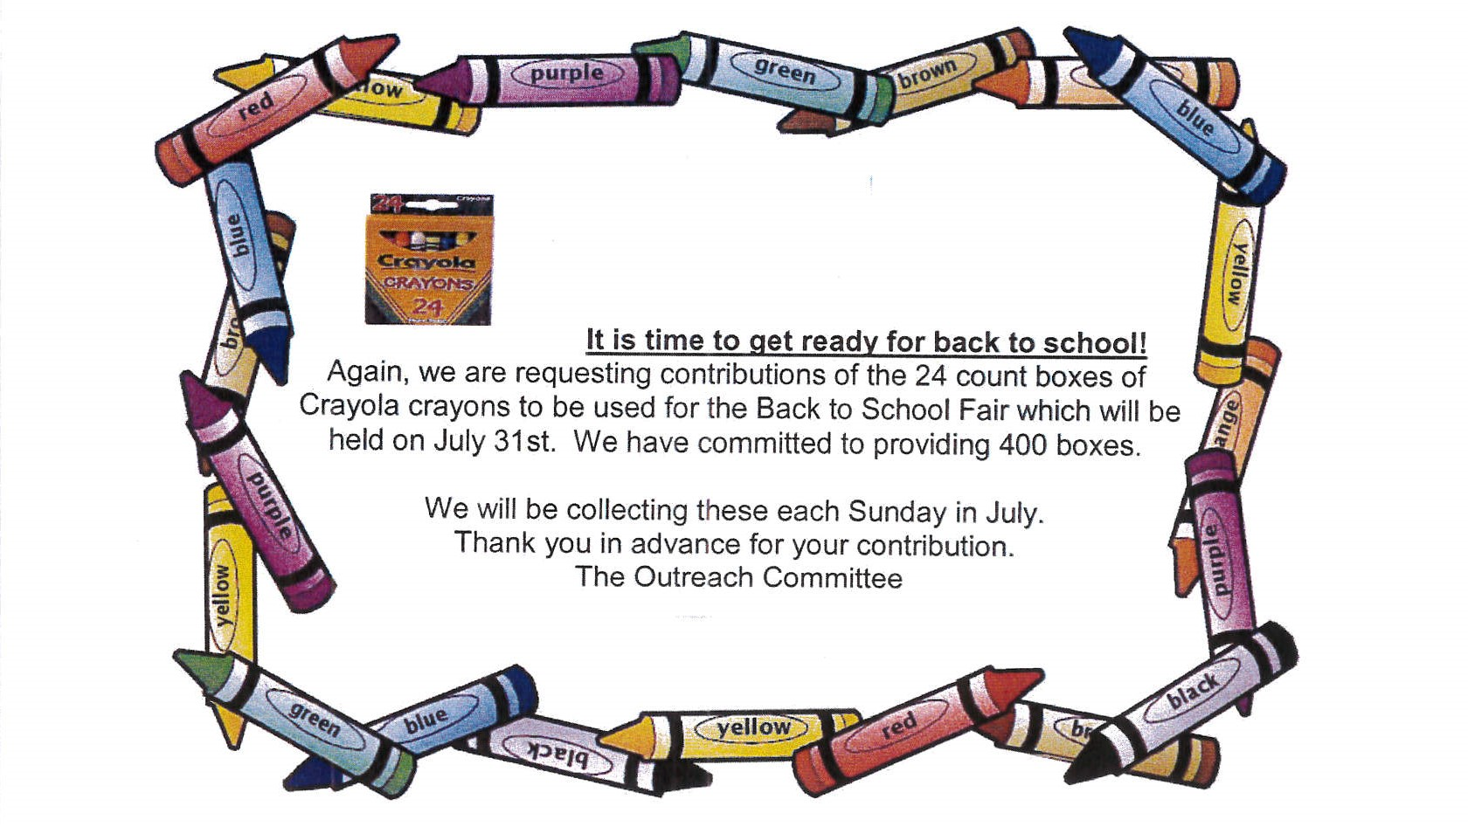



**News**

Things are taking shape in the Preschool! Inspections are under way, and we are following their recommendations to be ready for the new teachers to begin training on August 1, our families to attend an Open House on August 7, and students to arrive on August 8. Three rooms, some shelves and chairs are freshly painted, thanks to the wonderful help of many hands. The playground is getting spruced up and our Trustees are assisting with a walkway to the playground. Special thanks to Steve Day, Ray Fox, Lou Ellen Hartley, Cynthia Hobart, Lenn and Cheryl Koederitz, Mary Kwantes, Lindsey Spurgeon (Parent Representative) and Steve Zap for your hard work!

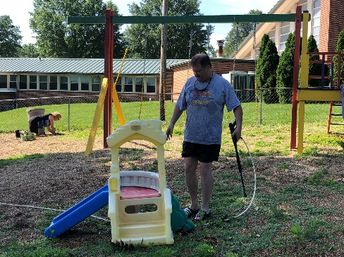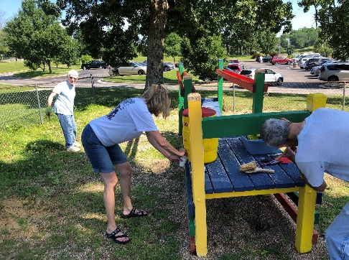

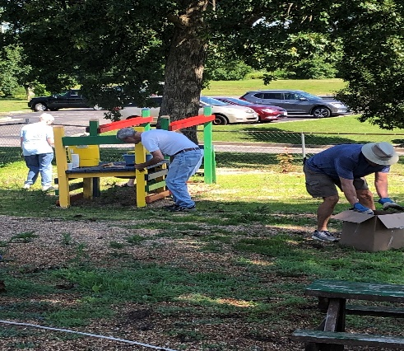

**Meet the Director:**

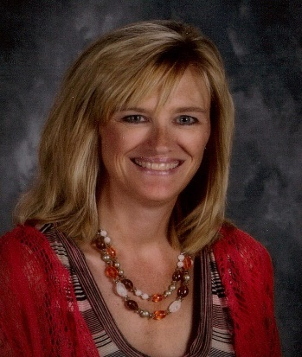

We are pleased to introduce ***Tracy James***!

Tracy is a 1984 graduate of Rolla High School. She attended Truman State and graduated with her Bachelors in Early Childhood and Elementary Education. She received her Master’s Degree from University of Missouri in Educational Leadership with an emphasis in Early Childhood and her Educational Specialist from Missouri Baptist in Instructional Leadership. She recently retired from public school teaching for the past 29 years. She is involved in different early childhood committees at the local and state level. She provides workshops at the local, state and national level and is a facilitator for Project Construct - a notional early childhood training group. Tracy and her husband, Doug, have 2 grown daughters and a grandson.

**From the Office**

Katie Sands, Office Manager

The Office will be closed Thursday July 4th in observance of Independence Day.



[This Photo](http://arkansasgopwing.blogspot.com/2015/06/history-of-freedom.html) by Unknown Author is ensed under [CC BY-SA-NC](https://creativecommons.org/licenses/by-nc-sa/3.0/)

**Farewell Dinner**

We would like to say thank you and wish a fond farewell to musician and friend Dr. Ilene Morgan as she prepares to move to St. Louis. Please drop by on Wednesday, **July 10**, any time from **5:00-7:00** p.m. in the private room at **Hoppers** restaurant, Rolla.

**First Friday Night Out**

Mark your calendars for Friday August 2. First Friday will meet at Bandanas at 6:00.

*Birthday wishes for July go out to: Ken Kwantes, Mary Kwantes, Clayton Read, Ed Schmidt, Ruby Malone, James Drewniak, Steve Day, Nancy Marlow, Morgan Long, Sophie Denbo, Janet Brown, Jessie Kimball, Christine Rueff, and Bob Yenzer.*



*Anniversary wishes for July go out to: Dean and Jan Sletten, Linda Rose and Robert Rogers, Lee and Ruby Malone, Luke and Kris Gutches, and Steve and Susan Bowles.*



***PRAYER REQUESTS***

**Please pray for: *Gail Drallmeier*** (friend ofSophia Leu, cancer), ***Connie DeWitt*** (continued health issues), ***Sarah Lucas*** (volunteer at GRACE, breast cancer), ***Mary Jane Potrafke*** (ongoing health issues),

***Robin Cabaret*** (cancer diagnoses, Betti Jo’s friend) ***Mary Williams*** (mild stroke), ***Carol Jessop*** (injured knee), ***Bob Mallory*** (Spinal stroke, Deanne Jackson’s father) ***Betty Lemp*, *Kelly Look*** (Surgery), Ken’s parents, ***Ken Kwantes*** (stroke) and ***Irene Kwantes*** (Dementia),***Mary Alofs*** (in rehab/ from fall**) *Marcia Brewer****,* ***Neil & Myrita* Davis** (Myrita on hospice care), ***Chuck Bennett****,* ***Tammy Bennett****,* ***Kathleen Dean*** (ongoing respiratory issues). The prayer request list will start over about every two months. If you have someone who needs put on or taken off the list, please contact Katie in the office.